Exam Study Tips
How to hit the books effectively and make the best use of your time.


#1. Pre-study Prep
• Engage in class by taking notes, asking questions, and listening carefully to lessons.
• Create a study schedule and stick to it! Plan to start well in advance
• Gather and organize your notes, unit reviews, tests, and study guide from the course. Make sure that you are studying the right stuff.
• Set up a distraction free zone that you can focus in. Devices and temptations should be out of sight. Make sure there is good lighting and a comfortable place to sit (or walk!). Avoid using your bed – save that for rest and relaxation.

#2. Soak it all in!
• Study for shorter blocks of time over several occasions. Twenty minutes study sessions will help you to stay focused. Take a movement break and re-energize. Repeat.
• Try several different ways to study. Simply reading class material over isn’t enough. Read, write, speak aloud, and listen. Draw charts and pictures to help you remember. Turn the topics into a song, rhyme, or acronym.
• Write out the key facts, definitions, and most important concepts to remember in your own words.
• Use flashcards to quiz yourself. Or have a family member quiz you.
• Study with a friend. Ask each other questions and share your thinking process to get the right answer.
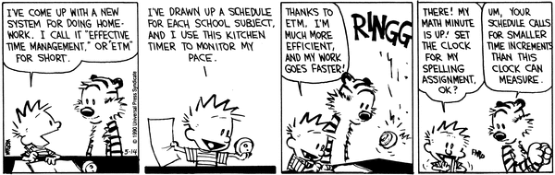

#3. Make the Best of Exam Day
• Have a good night’s rest before the test.
• Nourish your body and mind with a good breakfast.
• Don’t panic! Take deep, slow breaths, and keep a positive mindset. Tell yourself you can, and you will.
• If something was difficult to remember, try writing it out first on a scrap piece of paper or the margins before you start writing.
• Read each question carefully and make sure that you do what it is asking of you.
• Complete the whole exam. If you don’t know the answer, take your best logical guess. Leave no answer blank. If you are stumped on one question, move on to the next, and go back later.

HOW to Study Effectively

- Take notes on the key topics. Cornell Notes can be very helpful and are easy to do!
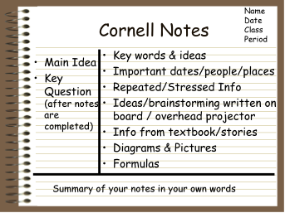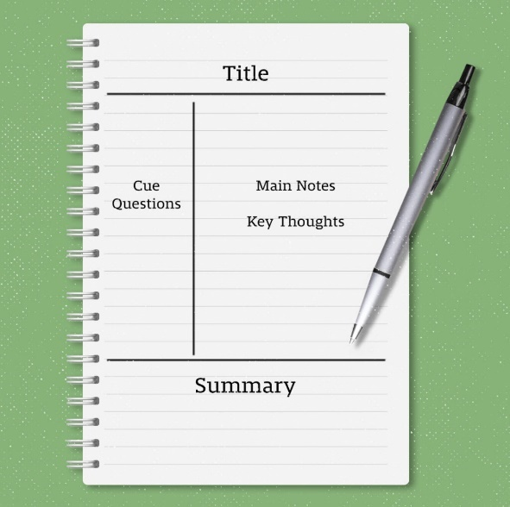
https://www.goodnotes.com/blog/cornell-notes
- Make Flash Cards! Put the question on one side and the answer on the other. Ask others to quiz you. You can also use a digital quiz platform like QUIZLET or STUDYSTACK.
https://quizlet.com/features/flashcards

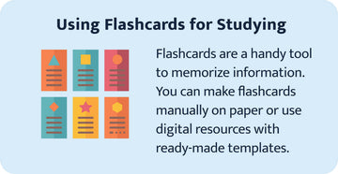

- * Read and Re-read your notes. READ NOTES OUT LOUD. According to research, when reading out loud, we form auditory links in our memory pathways. We remember ourselves saying it out loud, and not only do we form visual links, but we are also aided by auditory links. (https://www.bcbe.org/Page/9517)
4. Avoid Cramming!! Start now. Pay attention in class, using study guides, review regularly, and practice studying 2-3 times a week for 20 mins at a time for each course.

*Check out this website for more study tips! https://www.goodnotes.com/blog/how-to-study-tips

