R.E.M.S.

Middle Years Handbook

Learning today to improve tomorrow.

Table of Contents

Section 1: Learning

Section 2: School Life

Section 3: Behaviour

Section 3: Extracurricular

Section 4: Leadership

Section 1
Learning


Academics
While we offer many exciting opportunities to explore the world outside of the classroom, our core purpose remains academics. We see the acquisition of the Key outcomes in Mathematics and English Language Arts as fundamental in helping our students become contributing members of our democratic society.

Homework
In most cases our middle years students are not explicitly given “homework” (the exception being the expectation that they read each night). Despite this, there will be many times that students, do have work that must be completed at home. This is often the result of not completing assignments within the class time given. It is important that this work be completed in a timely manner since subsequent assignments often build upon the skills gained in the earlier work.
We encourage parents to establish a means of regular communication (planner, Edsby) with their child’s teacher in order to monitor when their child needs to complete work.

Guided Study
We understand that there are times that students cannot complete all assignments outside of school hours. To help with this we have established Guided Study. This program runs during our first break. Students either are assigned, or choose to go here for extra help. Adults supervise Guided Study in order to assist students. This allows students who need extra help to have some additional time with an adult within the regular school day.

Interventions
Our school carries out interventions in Mathematics, Reading and Writing. These interventions are based on Essential Outcomes (foundational skills within each subject). Students are placed in an intervention based on a particular outcome recently covered in class. A student may join a 4-week intervention on adding fractions and then not take part in interventions again that year, depending on their needs.

We have structured our timetables to ensure that students taking part in these interventions do not miss the instruction of new material. Instead, those students not taking part in an intervention on a particular outcome receive enrichment on that topic.

Middle Years Reading

“There is no more important homework than reading. Research shows that the highest achieving students are those who devote leisure time to reading, even when the school day and year are only mid-length and homework isn’t excessive. Recently, the largest-ever international study of reading found that the single most important predictor of academic success is the amount of time children spend reading books, more important even than economic or social status. And one of the few predictors of high achievement in math and science is the amount of time children devote to pleasure reading.”
― Nancie Atwell, The Reading Zone: How to Help Kids Become Skilled, Passionate, Habitual, Critical Readers
At REMS, we understand the importance of reading and its impact on not only future academic success but in a person’s ability to lead a full and rewarding adulthood. The best way to build skill in reading at the Middle Years level is simply to read as many books as possible, at or just above a child’s reading level. Just like any skill, skating in hockey or a set of dance movements, it is only through repetition and practice that a student can improve.
Therefore, we are asking students to read a number of pages at each grade level as indicated in the chart below. These books can be at various levels, but should be chosen in consultation with their teacher. While a number of these books may be lighter reading, most should challenge the student in order to build skills.
Grade | Page Expectation | Excellence Expectation  (see genres below)
5 | 3000 | 3500
6 | 3500 | 4000
7 | 4000 | 4500
8 | 4500 | 5000

While students will continue to receive silent reading time during the day, it is important that they spend at least 20 minutes a night reading. This could be done on the bus ride home or in the car on the way to a hockey game.
We also hope to encourage students to read books outside of their normal area of interest. These genres are marked on the spine of books in class libraries. In order to receive an Excellence in Reading Award students in 5/6 are expected to read books from at least 4 genres, in 7/8 the expectation is 6 genres.
Students who accomplish these goals will be recognized with a certificate during our year-end celebrations. Furthermore, students who complete books will be entered into a number of draws for reading materials during the year.

**We have made an effort to build classroom libraries filled with books that appeal to a wide-range of interest. As we purchase books, especially for the 7/8 level, we find that some can be considered Mature (due to content or language). When a book is identified, we first ensure that it is not too mature for the classroom. A book deemed too mature will be removed. If it remains in the library it is moved to a separate shelf and a capital M is placed on the spine. We encourage parents to speak to their children about what they are reading. If a parent feels that they do not want their child reading M books their teacher will be happy to find a similar book in the non-mature category. The vast majority of books in the libraries are not M, so they can enjoy a variety of others.**
Awards
Each year middle years students are eligible to receive a number of awards. These awards cover a number of areas, such as academic achievement and citizenship. Awards are our way to recognize the hard work, growth and accomplishments of our Middle School students.
The awards and their criteria are listed below:
The Brian Thordarson Award: Given to the grade 8 student who best demonstrates positive actions and interactions in all areas of school-life (academics, citizenship and leadership). Decided by the Grade 8 teacher in consultation with staff who have worked with the Grade 8s. (1 per grade)
Honour Roll with Merit: Given to any student who has received a majority of 4s in their core subjects (Math, ELA, Social Studies and Science). They can have no mark of 2 or less in any subject.
Honour Roll with Excellence: Given to any student who has received all 4s in their core subjects (Math, ELA, Social Studies and Science). They can have no mark of 2 or less in any subject.
Citizenship: Given to a student who is a positive member of the school community. The student not only exhibits a friendly attitude but also goes out of their way to improve the experience of others in our community. Decided by the classroom teacher in consultation with staff who have worked with the class. (1 per class)
Most Dedicated: Given to a student whose hard work has allowed them to make gains in their academic pursuits. Decided by the classroom teacher in consultation with staff who have worked with the class. (1 per class)
French Award: Given to a student who best exemplifies effort, interest and active participation in French. Decided by the French teacher (1 per class)
Reading Award: Given to any student who has meet their grade level page count, at a level appropriate as decided in consultation with the teacher.
Reading Excellence Award: Given to any student who has meet the excellence page count for their grade level, at an appropriate level decided in consultation with the teacher.
Music Award: Given to a student who best exemplifies effort, interest and active participation in Music. Decided by the Music teacher (1 per class)
Leadership Award: Given to any grade 7 or 8 student who has completed their volunteer time (35 points for Leadership Award; 50 points for Leadership with Excellence).
Male Athlete of the Year: Given to the Middle Year’s boy who best exemplifies the attributes of a Student-Athlete (this will include consideration of commitment, sportsmanship and leadership). Decided by a committee of coaches who have worked with them during the year.
Female Athlete of the Year: Given to the Middle Year’s girl who best exemplifies the attributes of a Student-Athlete (this will include consideration of commitment, sportsmanship and leadership). Decided by a committee of coaches who have worked with them during the year.
Section 2
School Life



Recess
Middle Years students are allowed to play with all other 5-8 students. This can be for group sports or simply hanging around. There is an expectation that this play be appropriate, if it is not then that student will be asked to play somewhere else.
It is important that students wear weather appropriate clothing, including outdoor shoes.
Lunch
Students may go uptown/home for lunch if they have permission from their parents/guardians to do so. If permission is given we ask that it be given for the whole year rather than on a daily basis.
Attendance
Students are expected to arrive on-time and prepared to learn. Attendance will be tracked in the office and parents/guardians will be notified at set intervals. Attendance can be checked at any time by parents through Edsby.
Dress Code
Students are required to remove hats and hoods when entering the building, and keep them off while inside. Hats/Hoods may be worn on the playground.
Students and staff are expected to dress in good taste and a manner appropriate for the workplace. Individuals who are dressed inappropriately will be asked kindly and discreetly to change. No item of clothing will be allowed that reference to drugs or alcohol, that is racist, sexist or discriminatory, or has any gang affiliations.
Electronic Devices
This year students will not be using personal electronic devices during school hours. These devices may be used on the bus to and from school but should be kept in backpacks or out of sight during the school day.
Students have access to school devices when they are necessary for learning. Personal devices are generally a distraction both to school work and socializing with classmates.
If a parent or student needs to contact the other during school hours we ask that they call through the office.
The misuse of phones results in the following: 1st and 2nd Teacher keeps phone until end of the day, 3rd – Principal keeps phone until the Parent comes into get it.

Section 3
Behaviour
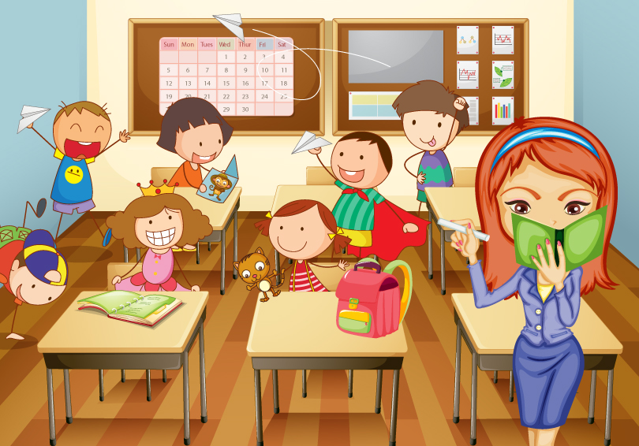

Student Behaviour
Our expectations of student behaviour at REMS are based around three pillars:

Responsibility Respectfulness Safety

We hope that students are able to be their best selves and act as contributing members of our school community. This extends throughout our school, on the bus, out on the playground and during outside events attended by our students. At the beginning of the school year, teachers will make the expectations specific to all areas clear to students.
There is no place, more important, or that students spend more time in than the classroom. Student behaviour here has the greatest impact on student learning. Negative behaviours in the classroom not only affect oneself, but can impede everyone’s learning. Therefore, during the first week of school teachers and students will co-construct expectations outlining what a positive learning environment looks like.
When a student is disrupting the classroom learning environment the teacher attempts to use a number of strategies to refocus them (including, but not limited to: reminder to class, proximity to student, quiet reminder to student, moving student, giving water-bathroom break to refocus). Afterwards the teacher will talk to the student in hopes that they will develop their own plan for restitution, but if necessary, the teacher will give a consequence for the action.
Unfortunately, these steps do not always work and as a last resort, the teacher must take action to preserve the learning community.

Continued Disruption of Learning
Once a teacher has exhausted all attempts to redirect a student back to learning they will ask the student to report to the office. The student will be given a quiet place to work and will be asked to complete whatever assignment their class is doing (with the expectation that this is work time and it should be done).
It is important that the student learn from this time away from class, if they return to class and continue to be disruptive their time away from class increases in the following way:
1st time – out for remainder of period.
2nd time – half a day from class.
3rd time – full day out of class (call home, letter sent to parents and Division office).
4th time – full day out of class (Parent meeting, letter sent to parents and Division office, creation/signing of Behaviour Contract).
It is only office visits that are tracked in this way, not the minor incidents dealt with by school staff (for example - getting in trouble for passing a single note would not result in this process).

**If a student is out of class for longer than a period their teachers will ensure they receive all work missed along with any instruction needed to complete it.**
Bottom Lines
While we understand that all children make mistakes and do our best to make these situations into learning experiences there are a number of actions that we cannot accept. These “bottom lines” result in consequences outside of those listed above, up to and including suspension from school.
The consequences of these types of actions are decided on a case by case basis. Considerations taken into account are severity, causes of action, frequency and willingness to find a solution by the student.
The bottom lines at REMS are:
- Violence towards peers or adults.
- Drug and alcohol use.
- Continued defiance towards staff.
- Use of inappropriate language towards peers or staff.

Section 4
Extra-curricular
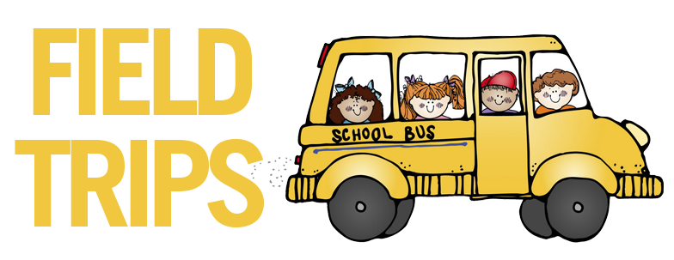



Field Trips
We feel that student field trips can be a powerful tool for learning. Therefore, we plan our field trips to accommodate all students, including making special accommodations when necessary. Access to curricular related field trips will not be limited unless a student has been suspended for the specific date of the field trip.
The collection of student fees at the start of the year are meant to cover the costs of most trips. On longer trips students may be asked to bring a bagged lunch, alternatively they may have opportunities to purchase a meal instead.
Students should exhibit positive behaviour on the bus and during the field trip itself. A student who is not responsible, respectful and safe may have their parents called to pick them up.
Some field trips, such as athletics or leadership require a student to complete a pre-requisite for going (ie. practices or volunteer hours). This opportunity is open to all students and anyone who meets these guidelines will be allowed to attend. Any actions necessary by students will be clearly articulated well in advance of the trip.

In the past we have asked parents to complete the Field Trip health form each time their child went on a trip. This year we ask that you fill it out (page 25) only once, covering your child for all trips. We do ask that you please notify us of any changes to your child’s health (ie. sudden allergic reaction) so that we are properly prepared.

School Athletics

REMS is committed to giving our students the widest number of possibilities when it comes to the Waterwolves athletic program. This includes:
Long distance running: September – October (Grades 4-8)
Volleyball: October – November (Grades 7-8)
Basketball: January – February (Grades 7-8)
Badminton: April – March (Grades 7-8)
Track: November – June (Grades 5-8)

Whenever possible we attempt to field a 7 and 8, boys and girls team for each team sport. We do encourage students in grade 6 to attend practices for these sports; this gives them exposure to the game. It is also possible that they may play in games if there are not enough grade 7 players to make up a team.
While we do periodically sell athletic jerseys, athletes are not obliged to buy one since the school has a set that students can borrow.
Our school’s policy is to accept any student who wishes to play a sport, without try-outs. Any student who may wish to take part should read the contract on page 27 with their parents and sign it. It lists the expectations and responsibilities of being a Waterwolves’ student-athlete.

Section 5
Leadership



Leadership Program
As students advance through the grades we ask them to take a greater role in our school community as leaders. Student leaders can help make our school a more positive place for everyone.
Grade 7 and 8 students can be part of our REMS Leaders Program. This program is explained on the contract on page 29.

EVERGREEN SCHOOL DIVISION
8.80 E: OFF – SITE ACTIVITY EMERGENCY MEDICAL INFORMATION
Parents: please fill this page in at the start of each school year.
Teachers will keep this documentation for all off - site trips.
Attach a separate page if more space is needed.
Date:
STUDENT’S NAME:
Birthdate:
Manitoba Health Registration Number: 6 digits
Manitoba PHN: 9 digits
Do you have additional Student Accident Insurance? YES NO
Any allergies? (specific drugs, certain foods, insect stings, hay fever, etc.)
Details regarding precautions, symptoms, treatment:

Any other medical conditions that may affect participation in certain activities?
Details:

Any medications?
Details: (name, reason for taking, dosage, storage, potential side effects/treatment of such, etc.)

Any dietary concerns?
Details:

Other?
Details:

EMERGENCY CONTACTS:
Parent / Guardian:
Home: Office: Cell:
Parent / Guardian:
Home: Office: Cell:
Other:
Home: Office: Cell:
PARENT SIGNATURE:
The personal information contained on this form is collected under the authority of the Public School Act and the Freedom of Information and Protection of Privacy Act for the purpose of participating in off – school site activities. If you have any questions about this form, please contact your school principal.

Riverton Early Middle School Athletic Contract
Player’s Name: ________________________
Team(s): ______________________________________________________
Welcome to REMS Athletics! Being a Student Athlete is a privilege and with privileges come responsibilities. As one of our athletes, we expect that players will comply with the following expectations and responsibilities.
1. Athletes will perform to the best of their abilities in all classes. You are a student first and an athlete second. Failing to complete assignments or submit work indicates an inability to handle the load of being a team member as well as a student. If teachers are not satisfied that you are working to your potential, you may be suspended from competition until improvement is shown.
2. Athletes will attend and be on time for all classes. Any player who has missed classes during the day will not be permitted to compete in games.
3. Athletes are expected to demonstrate citizenship and leadership in all classes. This includes showing respect to teachers and other students, demonstrating cooperation, and responsible behaviour at all times. Behaviour should not interfere with the learning opportunities of others.
4. Athletes will commit to participate fully in the Athletics program at REMS. This includes: a) Committing to all practices, games and team experiences. Planned absences should be discussed with the coach before the practice or game. b) Committing to staying on the team until the end of the season, unless mutually agreed upon by the coach and athlete. c) Athletes must choose to conduct themselves in a manner that displays respect for coaches, teammates, game officials, and opponents. d) Taking good care of uniforms and equipment issued for player use.
Remember that as an athlete you are representing yourself and REMS. Your conduct and sportsmanship should always reflect on you and the school in the best possible way. Coaches are expected to remove players who cannot demonstrate a high level of sportsmanship.
I, _______________________ as an athlete at REMS, recognize that there are high expectations for my conduct both during competition and as a student. I agree to adhere to the above expectations, and understand that if at any time I do not live up to the terms of this contract, my participation may be restricted or terminated.

________________________________ _____________________________
Student Signature Date

________________________________ ______________________________
Parent/Guardian Signature Parent/Guardian Name (printed)

Grade 7/8 Leadership Program Sign-up Sheet
I, ________________ am interested in taking part in the REMS leadership program during the 2022-2023 school year.
I understand that being a Leader entails a number of responsibilities on my part, including:
- Volunteering in the school to both improve and expand the opportunities available to my school-mates (examples of this are, running clubs for younger students, helping with intramurals or helping with other school activities and programs). I understand that I must earn 35 points by May long weekend through volunteering for these types of activities throughout the year. I must show a year-long commitment by earning at least 3 points during each month from October to May.

- Putting my best effort forward in my academics. This means that I do my best to complete all assignments and that if I am having trouble with a concept I seek out help.

- Interacting in a positive way with both my peers and the adults in the building. Part of being a leader in modelling positive attitudes and behaviours.

I realize that it is my responsibility as a member of the Leadership Program to embody all of these attributes. If I am not living up to my responsibilities in these areas my teacher will give me a warning and time to improve. I also understand that if I continue to act in a way that does not reflect positive leadership I will not be invited on the Leadership trip.
I know that my hard work and positive Leadership will be rewarded with an overnight trip in early June. This trip will be both a learning experience and a celebration of all that I have achieved.
My signature below indicates that I have read and understood the above information and wish to take part in the Leadership Program.
______________________ ___________________
Student Parent

